Alexander Baldree
07/22/26
Module 9.2 Project Part 4
CSD430

GitHub Link:
https://github.com/Panda-Alex21687/CSD430

Full Project Folder:
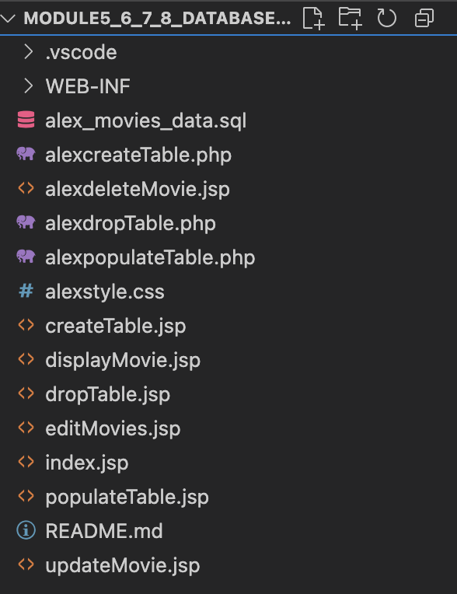

Module 9 Link in alexindex.jsp:

